MODULE END ASSIGNMENT - MYSQL
E-Commerce Customer Churn Analysis

BY
ATHIRA SASEENDRAN

INTRODUCTION
This project focuses on analysing an e-commerce customer churn dataset using MySQL. The project involves data cleaning, data transformation, and data exploration to understand customer behaviour and churn patterns. SQL queries and functions were used to handle missing values, correct inconsistencies, transform the data, and answer the required analytical questions.

- DATA CLEANING
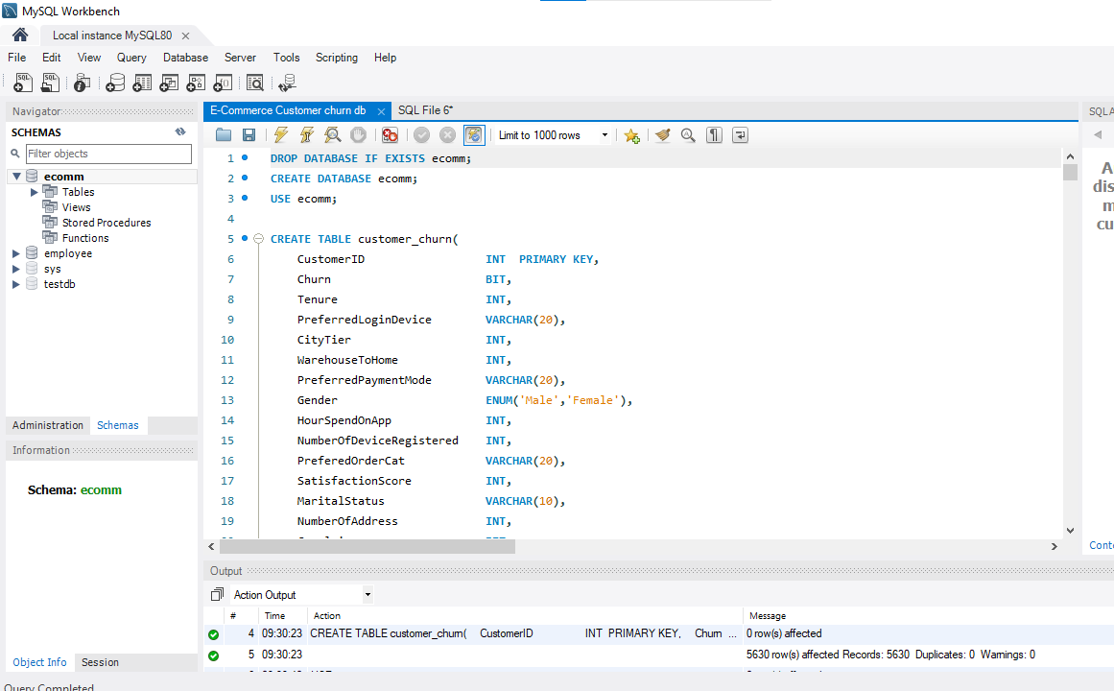
- Handling Missing Values
The dataset was checked for missing values before performing the cleaning operations.

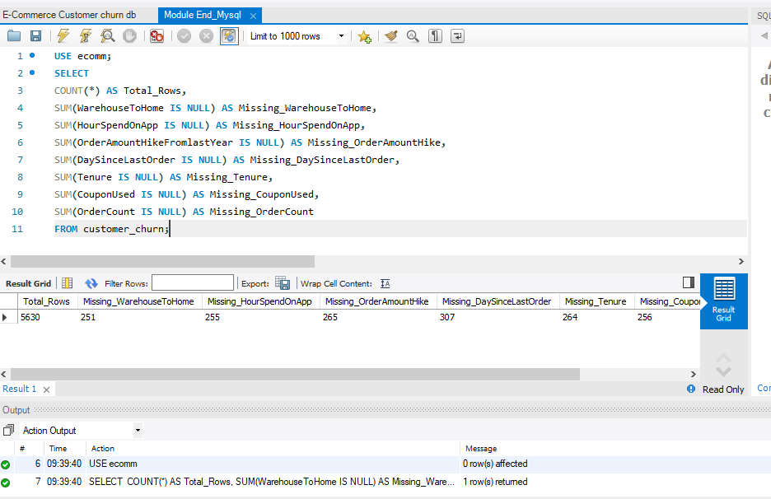

- Mean Imputation
Missing values in the required numerical columns ( WarehouseToHome, HourSpendOnApp, OrderAmountHikeFromlastYear, DaySinceLastOrder) were replaced using their mean values.

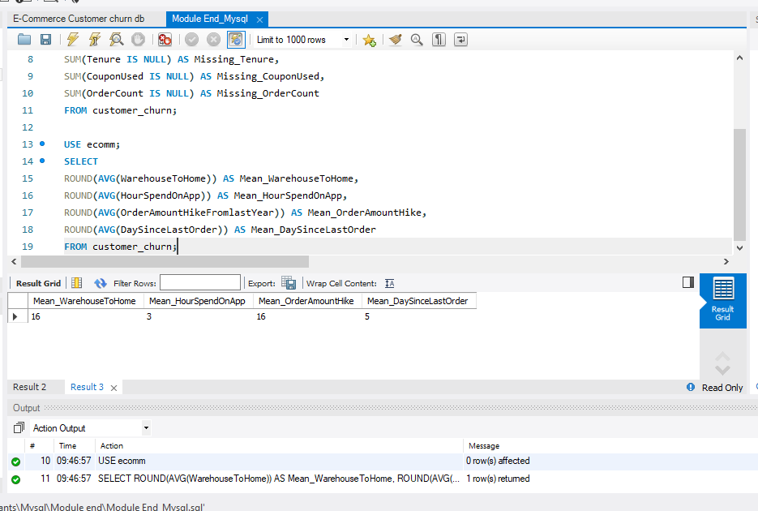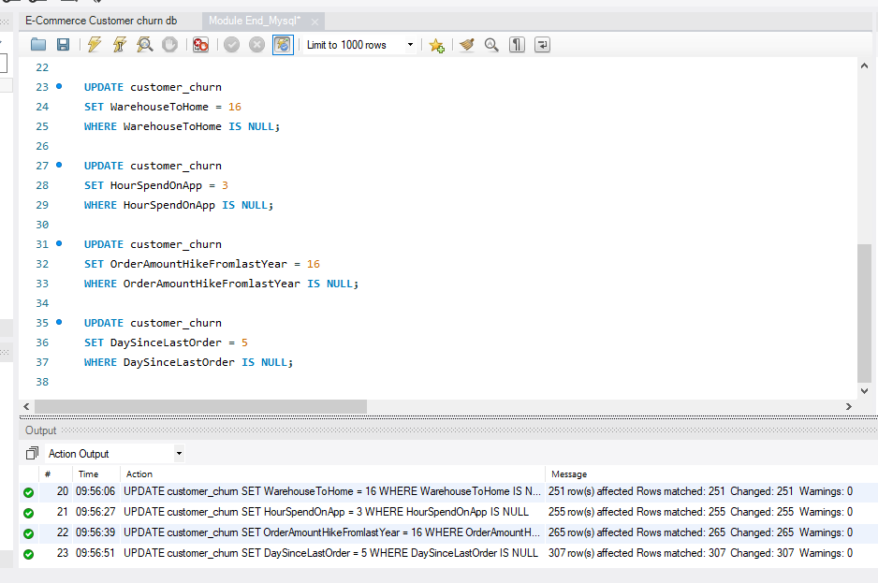
- Mode Imputation
Missing values in the required categorical/count columns (Tenure, CouponUsed, OrderCount) were replaced using the most frequent value (mode).
Tensure Coupon used
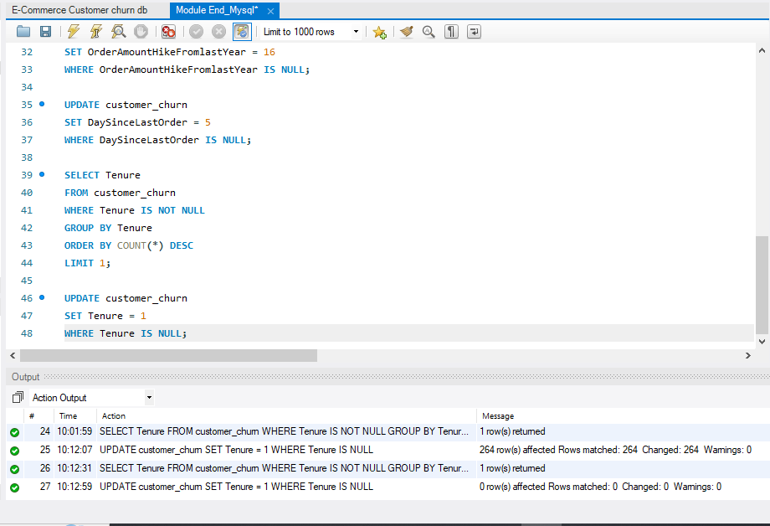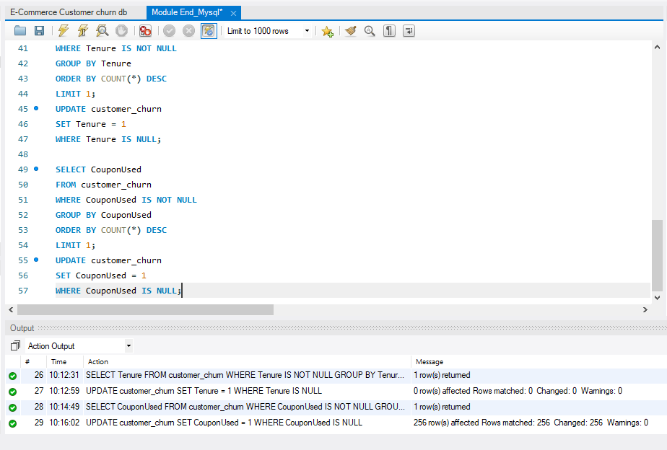
Order count
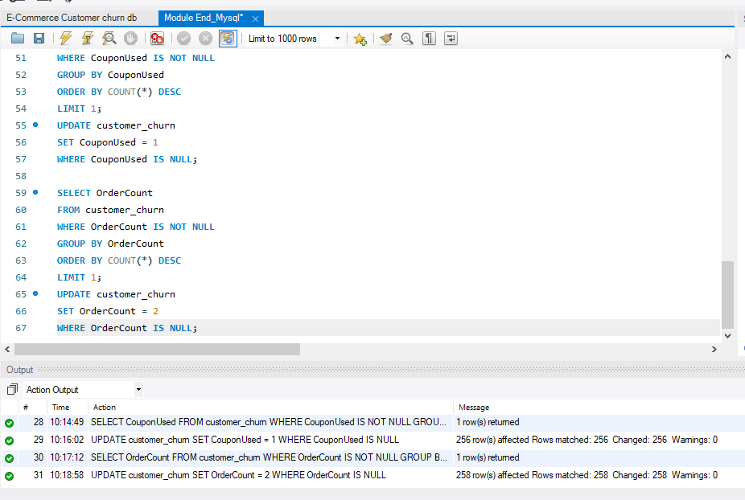

- Remove Outliers
Customers with WarehouseToHome values greater than 100 were identified and removed from the dataset.

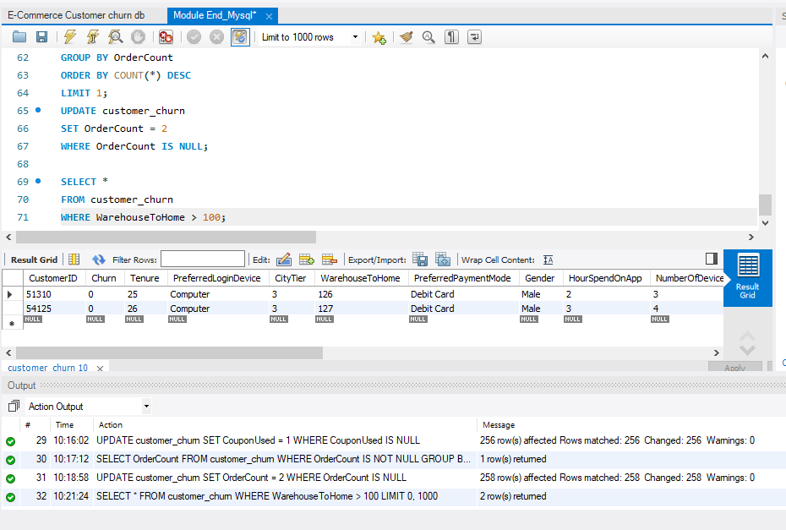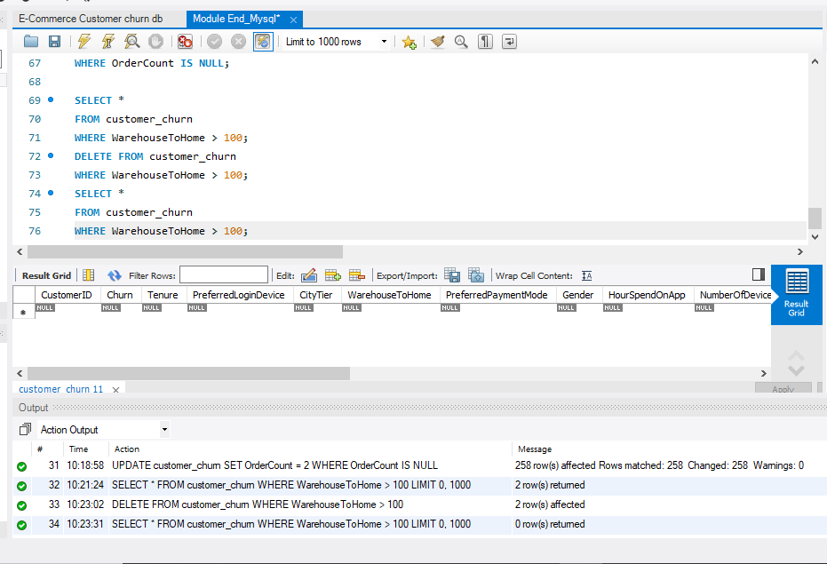

- Dealing with Inconsistencies:
Inconsistent values in login device, order category and payment mode were replaced with consistent names.
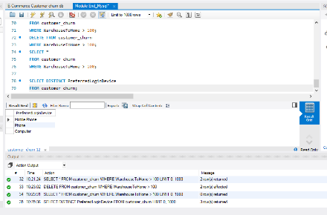

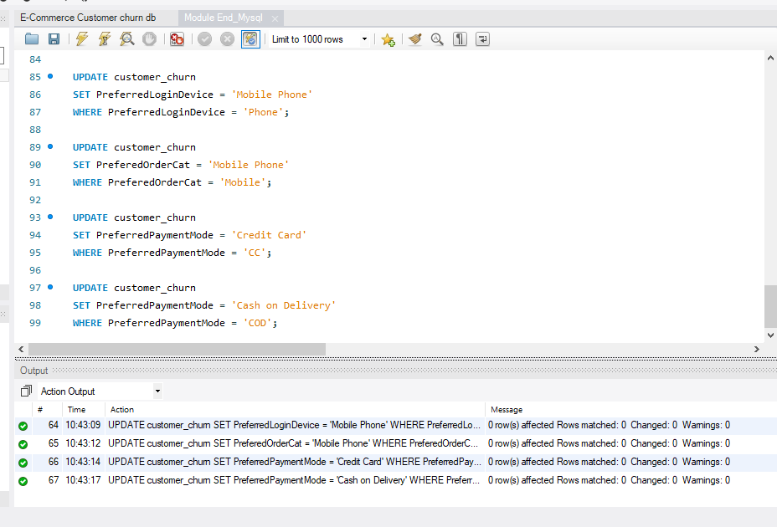

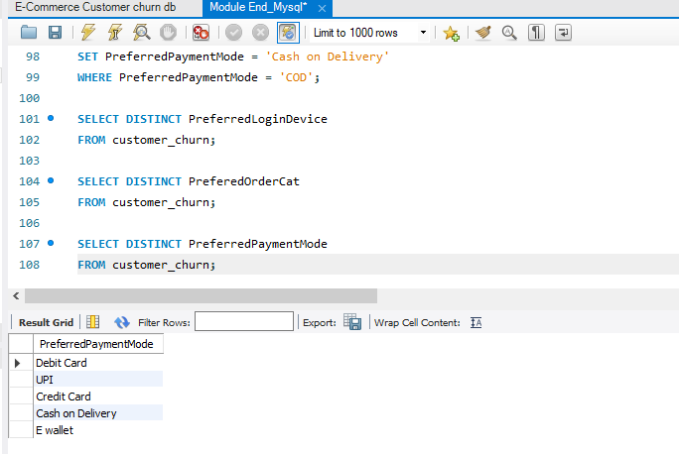

2. DATA TRANSFORMATIONS
a) Rename Columns
Renamed the column "PreferedOrderCat" to "PreferredOrderCat".
Renamed the column "HourSpendOnApp" to "HoursSpentOnApp".
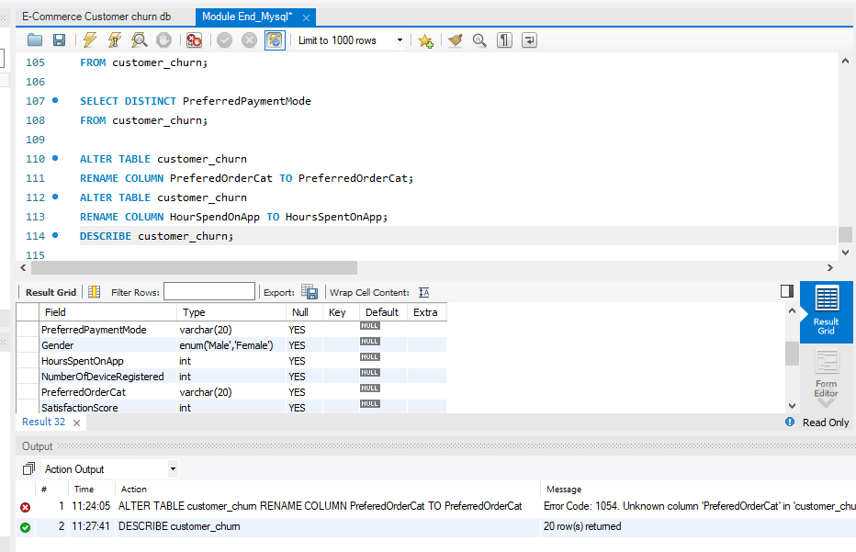
b) Create New Columns
ComplaintReceived and ChurnStatus columns were created to represent complaint and churn information clearly.
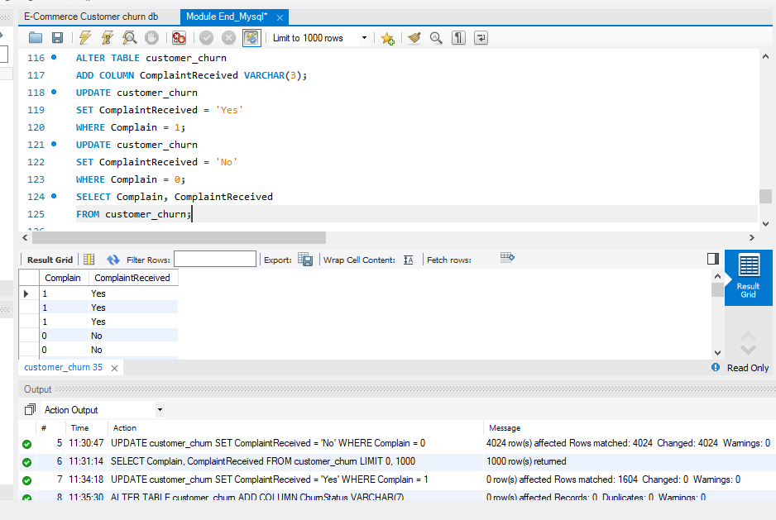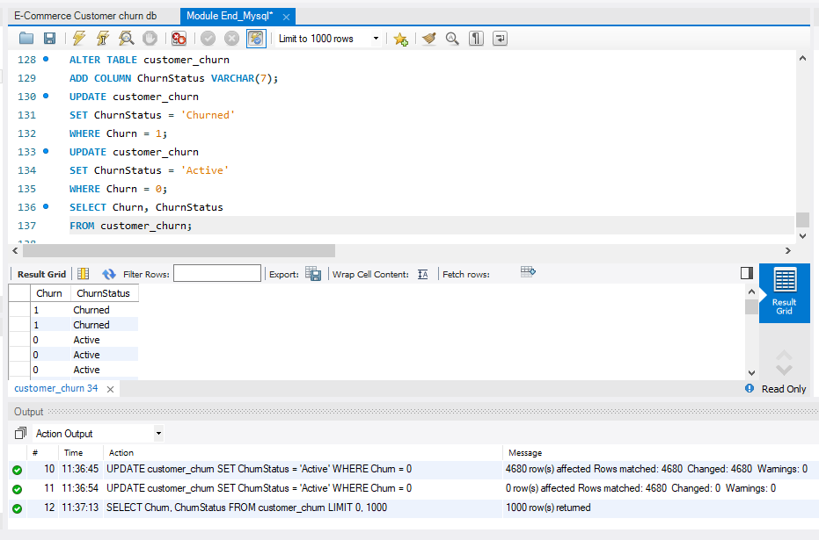
- Remove Original Columns
The original Churn and Complain columns were removed after the new status columns were created.
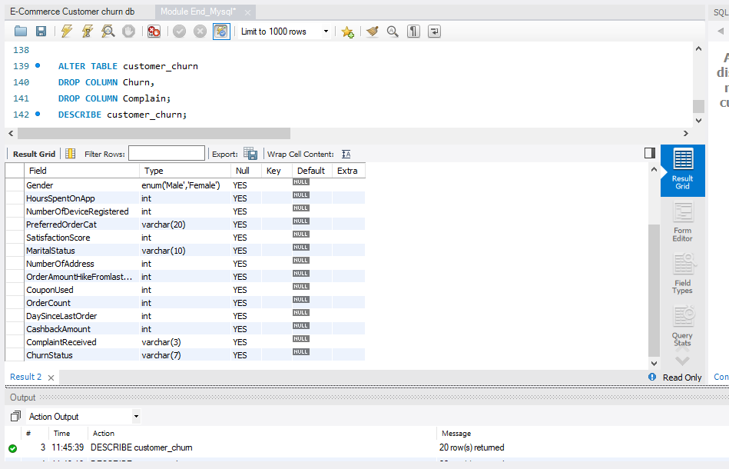
3. DATA EXPLORATION AND ANALYSIS
- The number of active and churned customers was calculated.
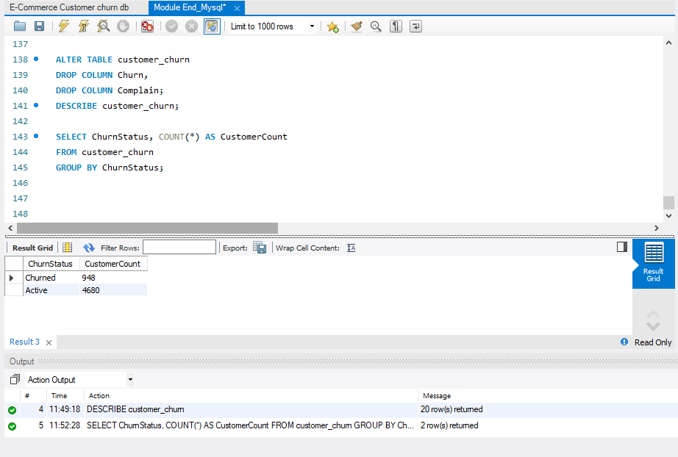

- The average tenure and total cashback amount of churned customers were calculated.
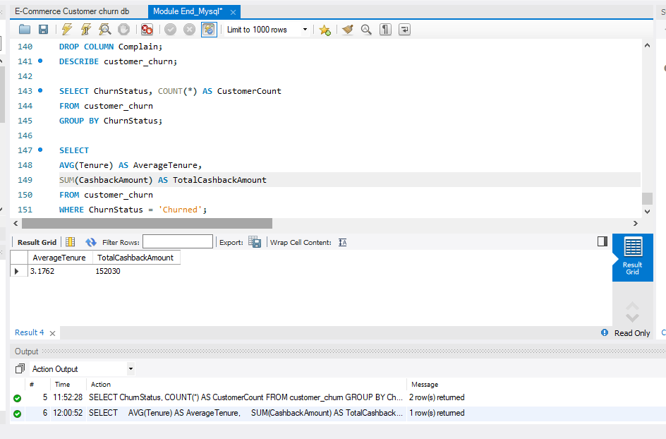

- The percentage of churned customers who made complaints was calculated.
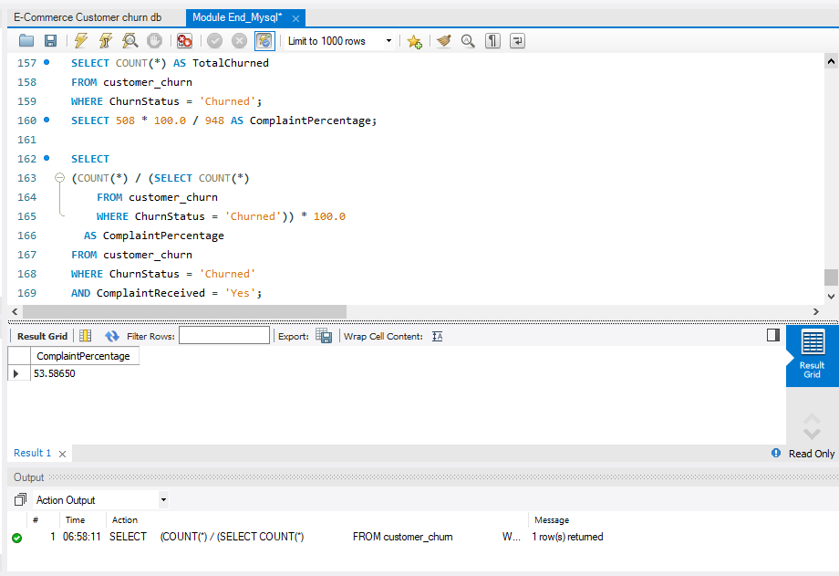
- The city tier with the highest number of churned Laptop & Accessory customers was identified.
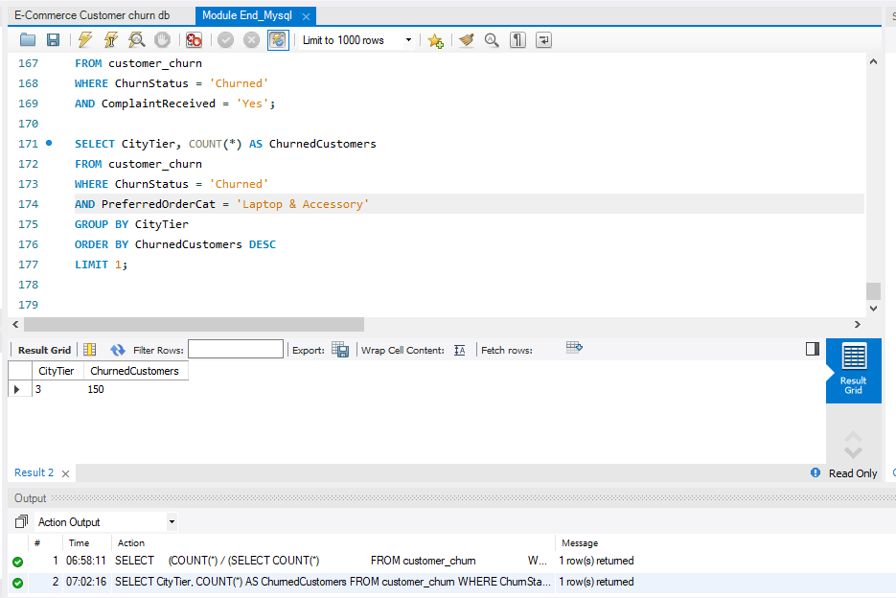

- The most preferred payment mode among active customers was identified.
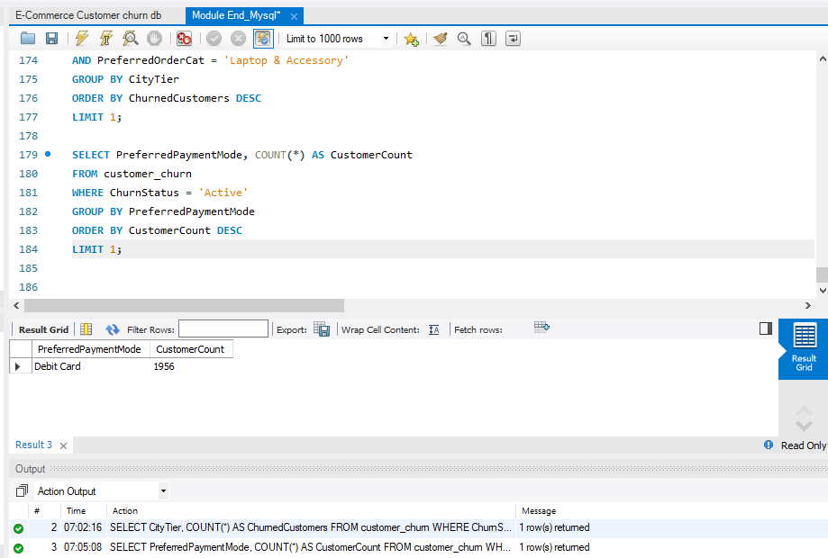

- The total order amount hike from last year was calculated for single customers who prefer mobile phones.

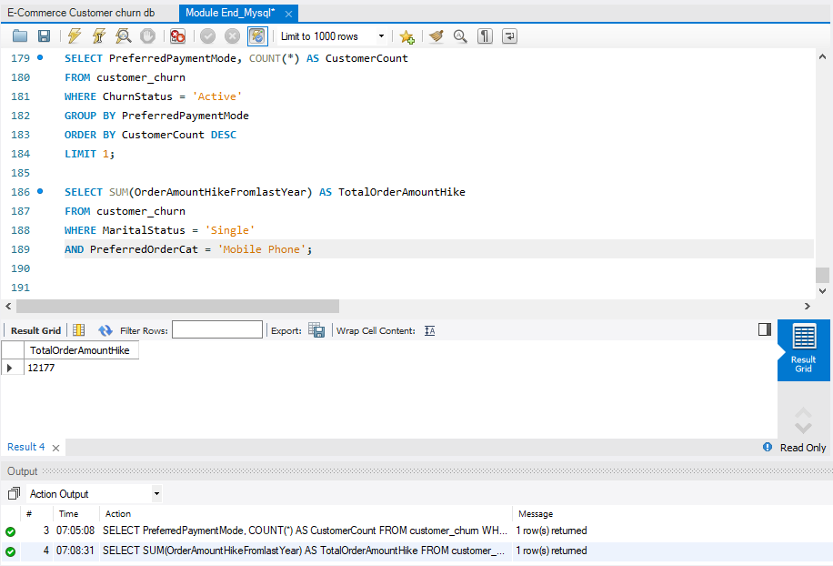
- The average number of registered devices was calculated for customers using UPI.
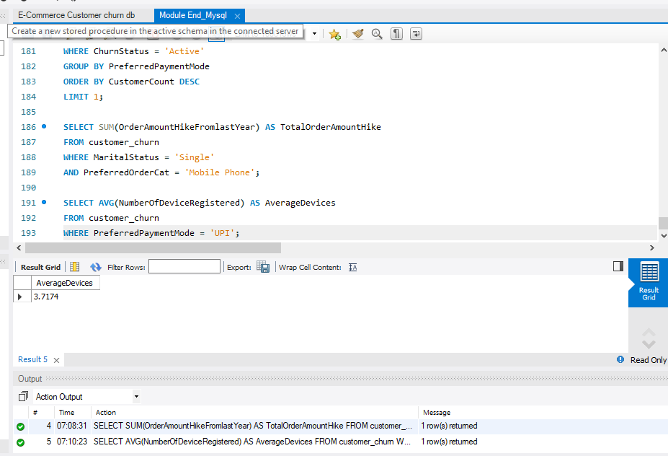

- The city tier containing the highest number of customers was identified.

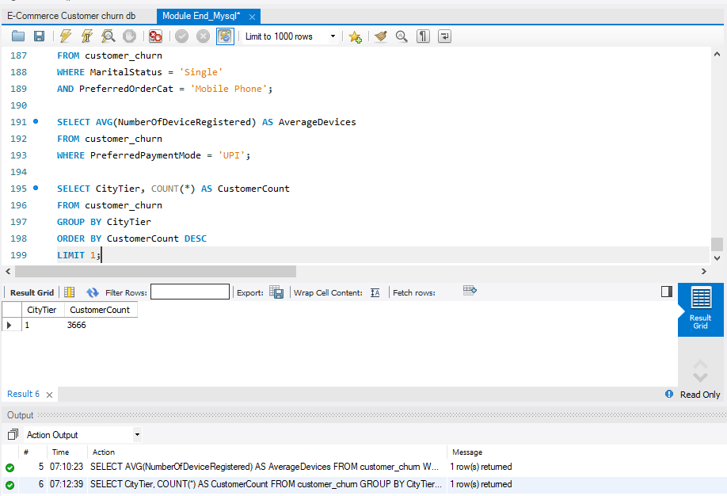

- The gender with the highest total number of coupons used was identified.
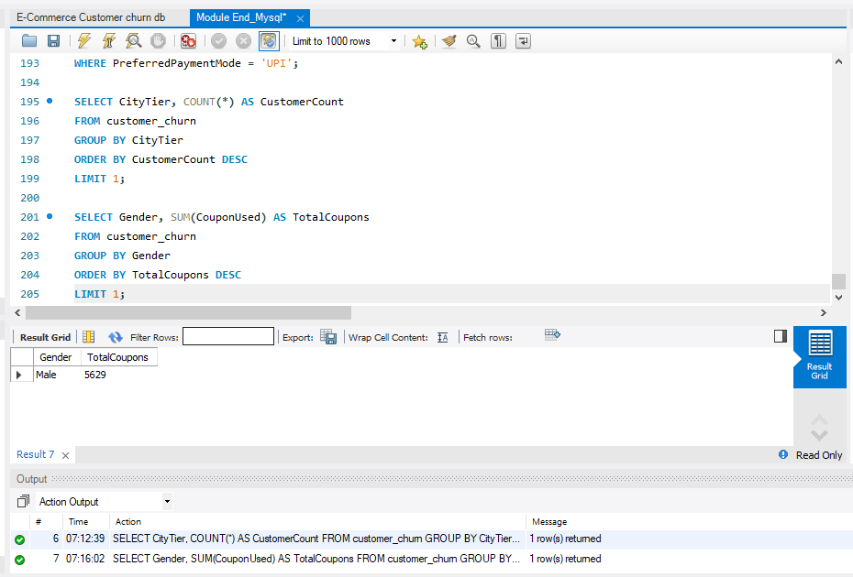

- The customer count and maximum app usage hours were calculated for each preferred order category.
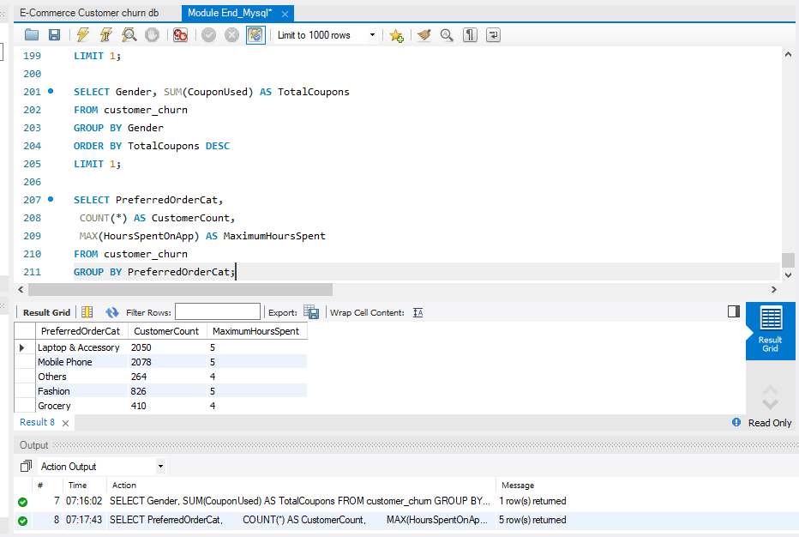

- The total order count was calculated for credit card users with the maximum satisfaction score.
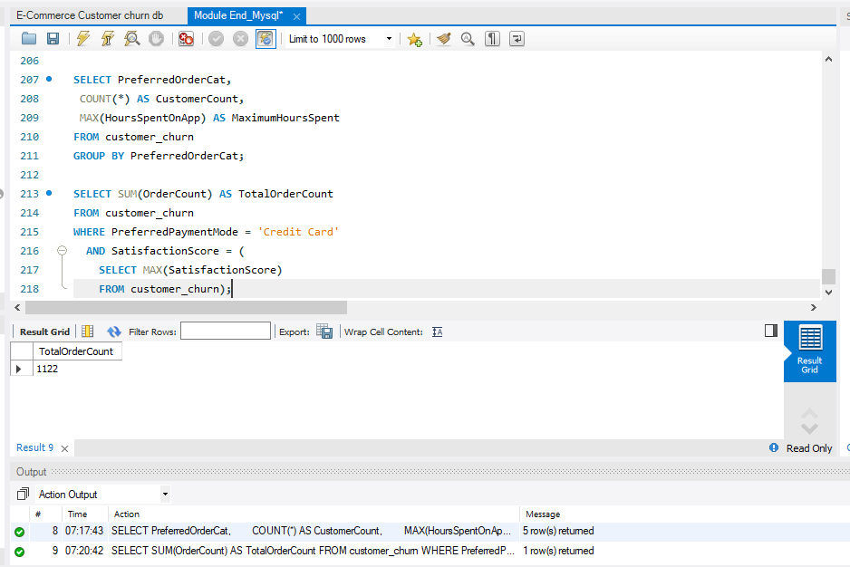

- The average satisfaction score was calculated for customers who made complaints.
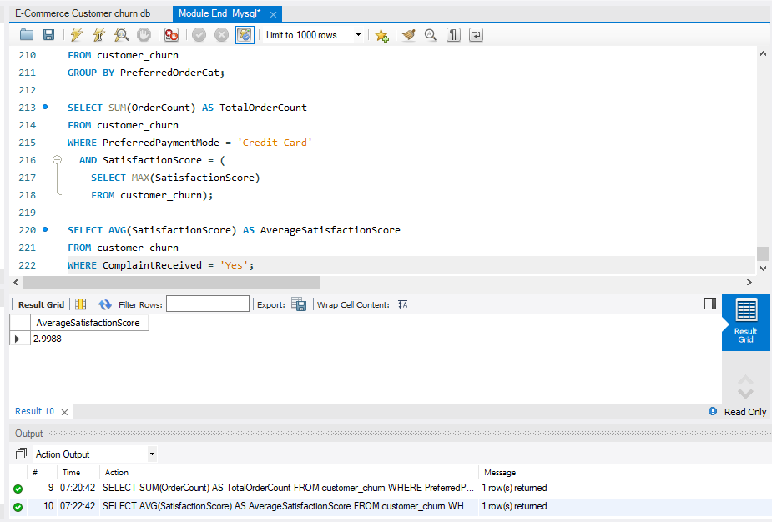
- Preferred order categories were listed for customers who used more than five coupons.
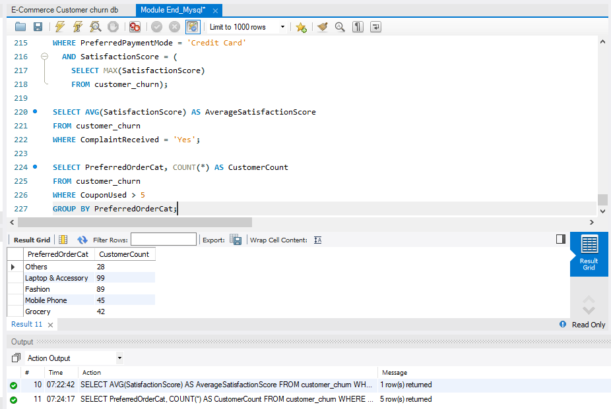

- The three preferred order categories with the highest average cashback were identified.
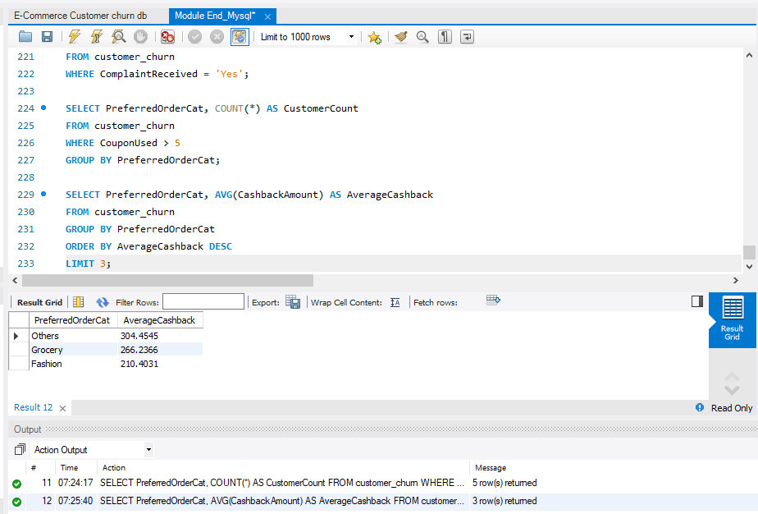

- Payment modes were identified where the average tenure was at least 10 months and total orders were more than 500.

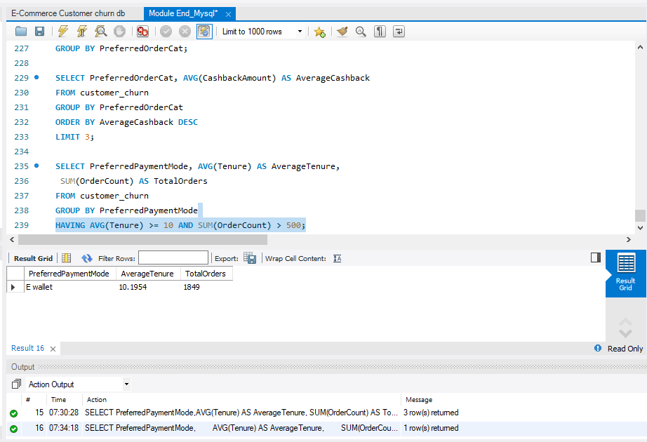
- Customers were categorized based on their distance from the warehouse, and the churn status breakdown was displayed for each distance category.

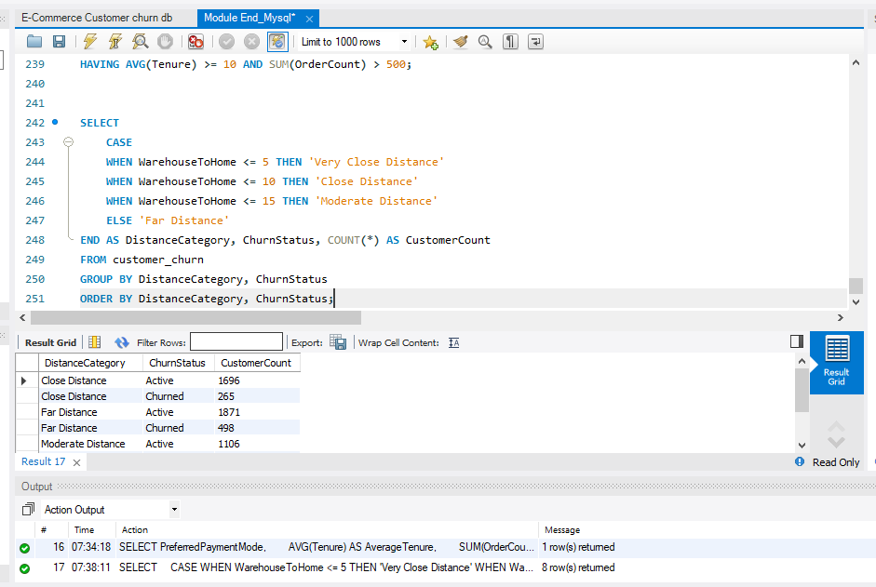

- Customer details were listed for married City Tier-1 customers whose order count was above the overall average.

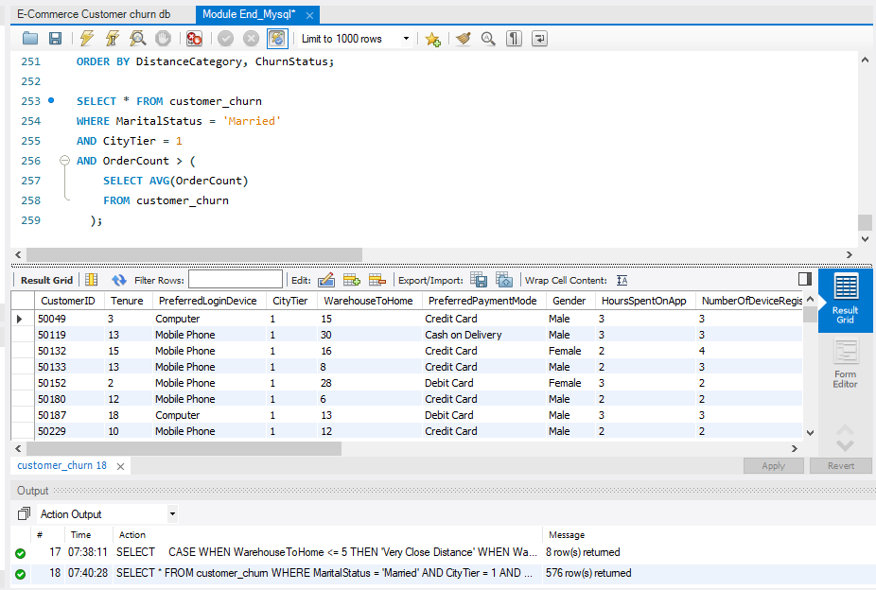

- Create Customer Returns Table
- A customer_returns table was created in the ecomm database and the eight given return records were inserted.

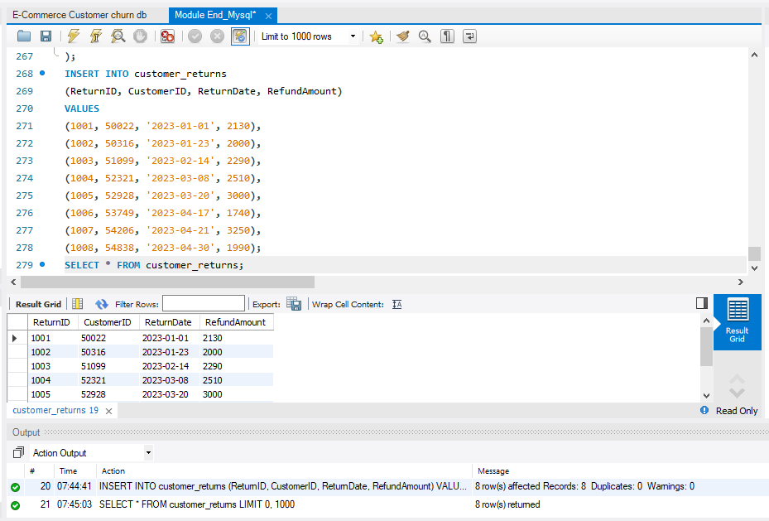

- The returns table was joined with the customer churn table to display return details for churned customers who made complaint

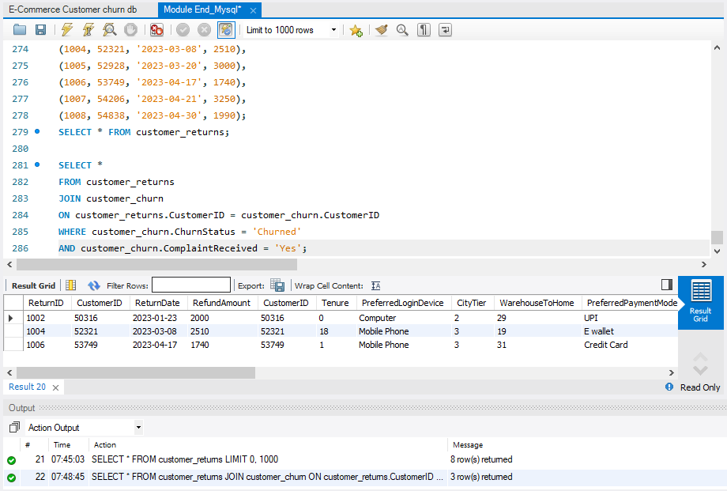

CONCLUSION
The project successfully completed the required MySQL data cleaning, transformation and analysis tasks. Missing values were handled, inconsistent records were corrected, unnecessary outliers were removed, and the dataset was transformed into a more useful format. The analysis questions were answered using aggregate functions, grouping, filtering, subqueries and joins. A separate customer_returns table was also created and connected with the customer data to obtain the required return information.

